French Revolution
Timeline Assignment

Rationale:
Timelines are a useful tool in helping historians and students of history understand chronology of events and cause-effect relationships. Completing this assignment will give you the opportunity to practice reading skills, research skills, thinking skills, organizational skills, and summarizing skills.

Your Task:
Using the information in your textbook, pp. 159-172, create a one-page timeline that identifies and discusses the important events of the French Revolution between the 1763 and 1795. You will also need to do some further research in the library and online.

Your timeline should be well-organized. It should use colours and symbols in a logical manner (people, events, documents) should be written in different colour ink than your text and/or highlighted. Each event should be listed in proper chronological order and briefly explained in your own words. You should stress the importance of each event. What happened? How did it change the situation?

Your timeline should include a minimum of two relevant graphics/pictures. You should write original captions identifying and explaining the importance of each.

Identify with a special symbol the one event you think was the most significant in the entire French Revolution. Explain and justify your choice. Use a separate box/area for your explanation or a separate page.

Items that should be on the timeline are:

Creation of the Marat murdered Danton executed
Committee of Public Safety 18 Brumaire coronation of Louis XVI
The Directory The “Terror” abolition of titles of the nobility
Estates General Meeting Tennis Court Oath abolition of the monarchy
“The Great Fear” Seven Years War Civil Constitution of the Clergy
D.R.M.C. Bastille (storming of) abolition of feudal rights
Execution of Louis XVI war with Austria “What is the Third Estate?”
Cahiers de Doleances “October Days” Louis XVI flight to Varennes
War of the First Coalition execution of Robespierre Marseillaise becomes the national
American Revolution Anthem of France
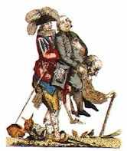
Calling of the Estates General Execution of Marie Antoinette
September Massacres Jacobins take Louis XVI in to custody
The Diamond Necklace Affair

An 18th century, pre-Revolution, French cartoon depicting the 3 Estates of the Ancien Regime.

Tips/Checklist:

- Use the exemplars in class to help you get started
- Construct a rough timeline first, use pencil only
- Read the relevant sections of the text, make additions to the timeline
- After your rough draft is complete, highlight key terms (use different colours for categories: people, events, laws …)
- Identify and explain the significance of each item on the timeline
- Find a minimum of two relevant pictures/graphics
- Write your own original captions for your pictures/graphics
- When your rough copy is finished, plan the design/layout of your good copy
- Plan to finish before the due date
- Ask Ms Bew if you need help
- Use this checklist

Evaluation:

Knowledge – of specific events and their significance, proper use of key terms, dates
Thinking – evaluation and assessment of events, the most important event, the significance of the FR
Communication – original writing, clarity, timeline design and organization, picture captions

Due Date: ____________

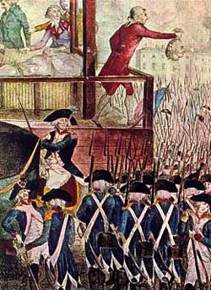
The execution of Louis XVI in Paris. The executioner shows the crowd the King’s severed head. Jan. 21, 1793.

