Leaders of the Enlightenment
CHY 4C/4U
Learning Goal:
Students are asked to evaluate the role that an individual played in the Enlightenment period. Students must be able to present information that recognizes the individual’s contribution to intellectual thought, politics, economics, etc. Evidence must be presented in a manner that draws conclusions and makes a reasoned argument.
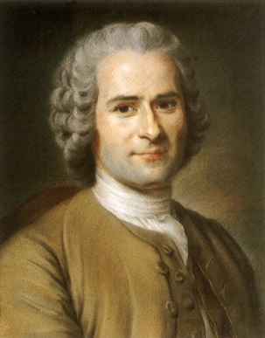
Success Criteria:
Complete all portions of the task below. The assignment will be assessed in all 4 learning categories. See marking checklist for specific details. An overall level will be given, as well.
Task:
- Draw one of the individuals from the list below. Feel free to trade with another student, assuming you both agree.

- Research your individual using valuable historical sources from the library, the databases provided by the library, or scholarly sources found online. Remember to keep track of sources by building a bibliography.

- Information to be included about each individual:
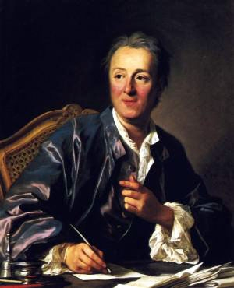
  - Birth and death, and brief biographical details
  - Accomplishments and achievements
  - Contemporaries: Who did this person hang out with? Did he/she have a following?
  - Best known for: What is this person’s legacy?
  - Criticism about his/her work (the positives and the negatives). What have others said about this person?
  - Your overall opinion about this individual, supported with evidence.
  - Endnotes or footnotes identifying information borrowed from sources.
  - Complete bibliography of all sources used, in Chicago Style format.

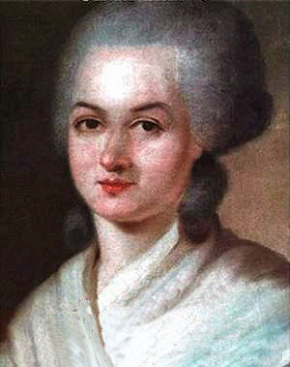
- Information can be presented in your choice of format. Options include, but are not limited to:

  - Essay
  - Research report
  - Obituary (more than just a death notice)
  - Poster
  - Powerpoint
  - Interview (write the script and get someone to be the talk show host)
  - Speech/oral presentation
  - Magazine article

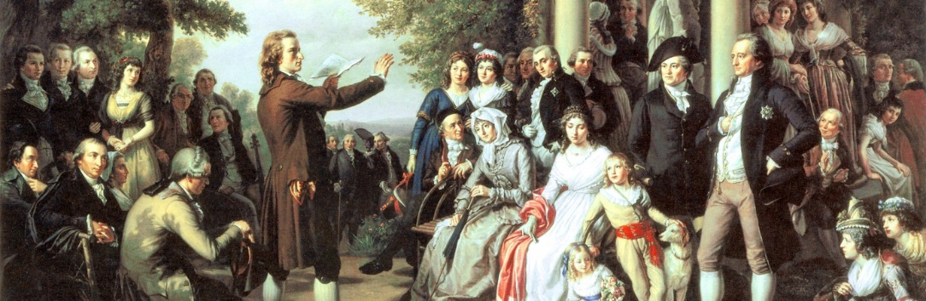
Leaders of the Enlightenment
Preparation Pages

Name of Individual: ___________________________________________
Birth: ________________________ Place: _______________________________
Death: _______________________ Place: _______________________________
Interesting facts about his/her life:
_____________________________________________________________________________________________________________________________________________________________________________________________________________________________________________________________________________________________
Achievements and accomplishments:
What was created? What was written? What role did this person play? Careers? Positions held?
____________________________________________________________________________________________________________________________________________________________________________________________________________________________________________________________________________________________________________________________________________________________________________________________
Contemporaries:
Who did this person associate with? Political affiliation? Societies? Friends? Were they famous while alive?
____________________________________________________________________________________________________________________________________________________________________________________________________________________________________________________________________________________________________________________________________________________________________________________________
Best Known For:
What was their most important or significant achievement? Why?
____________________________________________________________________________________________________________________________________________________________________________________________________________________________________________________________________________________________________________________________________________________________________________________________
Criticism about their work (the positives and the negatives)
________________________________________________________________________________________________________________________________________________________________________________________________________________________________________________________________________________________________________________________________________________________________________________________________________
Your overall opinion about this individual, supported with evidence.
Try make this something similar to the Weldon 9-sentence-paragraph. Provide an intro, conclusion, and 3 pieces of evidence with your analysis.
______________________________________________________________________________________________________________________________________________________________________________________________________________________________________________________________________________________________________________________________________________________________________________________________________________________________________________________________________________________________________________________________________________________________________________________________________________________________________________________________________________________________________________________________________________________________________________________________________________________________________________________________________________________________________________________________________________________________________________________________________________________________________________________________________________________________________________________________________________________________________________________________________________________________________________________________________________________________________________________________________________________________________________________________________________________________________________________________________________________________________________________________

Complete bibliography of all sources used.
Write down the bibliographic information from each source that you find. Do it as soon as you find the source.
________________________________________________________________________________________________________________________________________________________________________________________________________________________________________________________________________________________________________________________________________________________________________________________________________________________________________________________________________________________________________________________________________________________________________________________________________________________________________________________________________________________________________________________________________________________________________________________________________________________________________________________________________________________________________________________________________________________________________________________________________________________________________________________________________________________________________________________________________________________________________________________________________________________

Leaders of the Enlightenment Assessment
CHY
Success Criteria For This Assignment | Level | Yes | No
Knowledge
- Biographical information is complete and accurate

- Accomplishments and achievements are accurate and complete

- Criticisms (positive and negative) are explained

Thinking
- Legacy is identified and analyzed

- Student’s opinion is clear and well-defended.

- Sources used are well-chosen and scholarly
Application
- Effective use of class time and technology

- Use of footnotes/endnotes is complete and accurate

- Bibliography is present and complete (minimum 3-5 sources)

Communication
- Spelling and grammar are accurate

- Format chosen is appropriate, neat, and well-organized

- All information and ideas are communicated clearly and concisely

What you did well:
____________________________________________________________________________________________________________________________________________________________________________________________________
Next time I would suggest …
____________________________________________________________________________________________________________________________________________________________________________________________________
Overall level:
___________

