Rewriting history? That’s how history is written in the first place

Opinion: As the debate over John A. Macdonald rages on, we must remember that revisiting history is an act of making a new history
David Moscrop
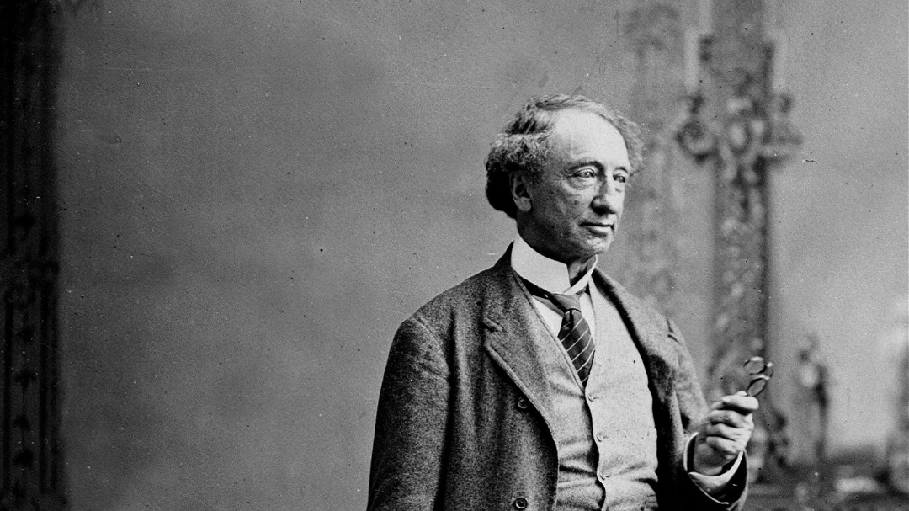
August 25, 2017
Sir John A. Macdonald. (1815-1891) National Archives of Canada/CP
If you’ve been following the debate over whether Sir John A. Macdonald—prime minister, lawyer, architect of Confederation, corrupt politician, and functional alcoholic—should have his name removed from schools and buildings in Ontario, you’ve likely encountered histrionic reactions from those who decry such efforts as erasing history or re-writing our past or genetically engineering political correctness into Canadians.
The “history is under attack!” responses are predictable, but that’s not their critical deficiency. No, the greatest weakness in that argument is that it fetishizes a particular account of history, ignoring what history is, what it represents, and what it does. Many of the quickest takes about the “problem with re-writing history” are sops for old-school culture, mopping up buckets of indignation from those whose historical experiences and values seem rather well-represented in our official accounts of our past, as well as our acknowledgements and celebrations of events and figures.
This all started last week when the Elementary Teachers’ Federation of Ontario (ETFO) cracked open Pandora’s box by passing a motion to “examine and rename schools and buildings named after Sir John A. Macdonald.” The impetus for dropping the sometimes-beloved whiskey-soaked codger? “[H]is central role as the architect of genocide against Indigenous peoples.” I’d say the punishment fits the crime here, except it doesn’t; being structurally complicit in the deaths of many peoples and their culture while initiating an ongoing history of violence against the descendants of those peoples seems to warrant a rather more severe reprimand. But let’s set that aside.
This debate has been a long time coming. We should have had it in earnest a long time ago, given changes to the makeup of Canadian society and the longstanding injustices that remain woefully and shamefully under-addressed or unaddressed entirely, especially our relationship with Indigenous peoples. But the debate thus far hasn’t sufficiently acknowledged one crucial consideration: revisiting our history—reassessing it and how we think about it—is central not only to correcting the record in some cases, but also to moving forward as a country. History is not a static moment or series of moments; history is an ongoing project that connects past generations to the present, and it is built by human beings who make choices about what we admit to, what we ignore, what we celebrate, and what we condemn.
The preferences, norms, and values of a society change over time; the present is a reflection of what we want to represent us, right now—and so it is perfectly reasonable, and often necessary, for a country to revisit what in its history it chooses to emphasize and celebrate. This is, after all, how history is written in the first place.
Now, no one is suggesting that we completely strike Macdonald and other historical figures who are implicated in practices or actions we now find unacceptable or abhorrent from the history books. No one is arguing that we should forget Macdonald’s legacy as a critical part of Confederation. We’re not turning the porch light off and pretending we’re not home should he pop by.
All the ETFO and others are suggesting is that in some instances, we should choose not to celebrate and honour Macdonald by naming schools and buildings after him, which seems rather reasonable given that he was complicit in the abusive and murderous residential schools system as well as other (what we would now call) crimes against Indigenous peoples. If a democratic society chooses to live its history by shifting who and what it emphasizes and celebrates, then bully for it—especially if a shift in focus is used to foreground and address historical and contemporary injustices and to renew efforts at healing persistent wounds. This reassessment of the past and how we live in the present is only controversial if your understanding of history is static and your commitment to your country is monolithic.
Historian Sean Carleton captured this line of argument well, reminding us that history is always political and never objective, and that while facts are objective, history is not. “We need to remember that both naming and renaming are political things that need debate,” Carleton said in a piece that ran in the Calgary Herald. “Names are not neutral and that’s what I think is somewhat frustrating about the claim that changing the name is erasing history.” Precisely.
Cherie Dimaline, a Métis woman, wrote in Today’s Parent that history is indeed political, as well as ongoing and alive in the present, especially the Canadian history of violence against Indigenous peoples. “It strikes me as particularly ironic that they’re worried about history being lost. After all, the very fact that we send our children to schools named after the architect of Indigenous genocide through the residential schools attempts to remove our story, negate our well-being and ignore our continued survival,” she writes. “It is, in fact, a push to actively lose history….I hear all the time that colonization happened 400 years ago, that it’s so far gone that we shouldn’t be so sensitive…. Colonization didn’t happen 400 years ago; it began 400 years ago and continues today. Right now.”
Carleton and Dimaline remind us that history is ongoing and disputed; as we live, and make choices about how we remember and view our own histories, we create history anew, whether we care to acknowledge that or not. Those who oppose dropping Macdonald’s name from schools and buildings smuggle in a comfort with a broad conceit of history that isn’t universally shared, one that carries water for some but not for others; one person’s “re-writing of history” may be another’s rectification of history. A sophisticated understanding of where we come from takes this understanding of history for granted as a starting point and accepts that the past is more than a series of fixed written records, and our conception of it certainly isn’t objective.
As long as we humans have had history, we’ve been re-writing it. In fact, our history is the history of “erasing”—that is, revisiting and revising—our past. Canada is no exception to this practice, and nor should we be. Indeed, it may be the case that the best way to continue as a country is through an ongoing and vigorous debate about who we are, where we come from, what we value, and what we choose to celebrate, emphasize, and honour in our public spaces.
Maclean’s http://www.macleans.ca/opinion/rewriting-history-thats-how-history-is-written-in-the-first-place/

