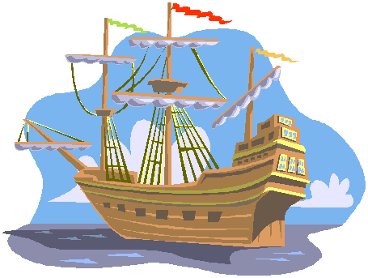

Influence of Religion

The Political Situation

Consequences of Encounter

Consequences of Exploration

Who went where? And, what did they find there?

Economic Changes that encouraged exploration

Notable People and What Their Role Was. Why are they significant?

Science that allowed exploration to happen. Identify and give the significance of these developments.

The Age of Exploration and Encounter