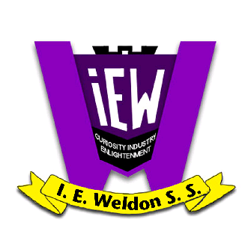
I.E. Weldon Secondary School
Canadian and World Studies Department
CHY4UR: World History since the End of the 15th Century

Teacher: Ms. M. Bew

Room 224 (705) 324-3585 ext. 19008
www.msbew.weebly.com mairi.bew@tldsb.on.ca

Textbook: The West and the World, Gage, 2002 ($75)
Rationale: This course traces major developments and events in world history since approximately 1450. Students will explore social, economic, and political changes, the historical roots of contemporary issues, and the role of conflict and cooperation in global interrelationships. They will extend their ability to apply the concepts of historical thinking and the historical inquiry process, including the interpretation and analysis of evidence, as they investigate key issues and ideas and assess societal progress or decline in world history.
Unit 1: 1450-1650 The Renaissance
Unit 2: 1650-1789 The Enlightenment
Unit 3: 1789-1900 Industrial Revolution
Unit 4: The World Since 1900

Evaluation and Assessment

All work will be assessed using the academic skills of knowledge & understanding, thinking, application, and communication.

Summative Evaluations – 70%

Tests 20%

Essay 10%

Seminar 10%
Unit Assignments (including essay & seminar prep) 30%
Culminating Tasks– 30%

Final Exam (exam period) 30%
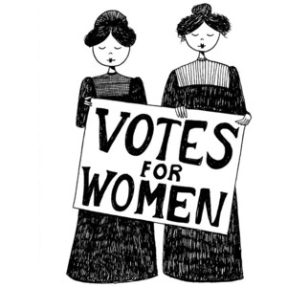
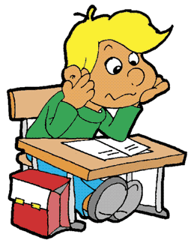

Assessment Tools

Small group presentations
Minor essay or report
Major research essay (multiple components)
One major seminar presented in January
Unit Tests and Readings
Final Exam

You will also be assessed in the following categories, based on daily work:
Responsibility, Independent work, Initiative, Organization, Collaboration, Self-Regulation

Deadlines
Students are expected to meet all deadlines set out by the subject teacher. Failure to do so will result in a grade of ZERO. All essays, and presentations, must be submitted at the start of class on the day they are due. Any assignment that is late will have a 10% deduction. Not done is not acceptable. This is a very bad situation to find one’s self in. It also means that the teacher has to nag! Small assignments may not be submitted once the work has been returned to other students.

Missed Evaluations

Students who are absent on the day of an evaluation are expected to write the day they return to school or at a time agreed upon by the teacher. Arrangements regarding planned absences must be made with the teacher in advance. Email is the best way to do this.

Attendance
Good attendance is essential for academic success. Students who have chronic problems with attendance undermine their ability to gain a credit.

Reporting
Student achievement will be reported in all courses at the following times:
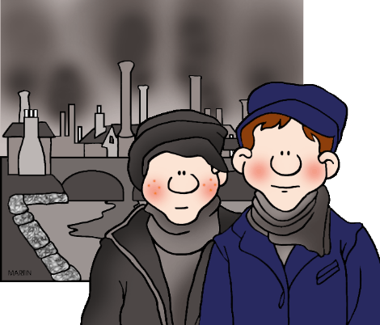
Mark Update Week – 16-20 October
Parents’ Night – 26 October – 4:30 to 7:00 p.m.
Interim Report Card Issued – 17 November
Mark Update Week – 18-22 December
Final Report Card Issued – 9 February 2018

Expectations

- Be here on time and ready to work. Have all books and supplies with you. Have all homework completed. PUT YOUR PHONE AWAY!!! I will confiscate it if required.
- Remember the three R’s: Responsibility, Reliability, and Respect. Conduct yourself accordingly with your teacher, your peers, classroom property, and most importantly, yourself.
- TCOB (Take Care of Business) at all times! Report to your teacher immediately upon returning from an absence.
- Take active responsibility for your learning. Keep track of all marks and all of your educational goals. Keep an open line of communication with parents or guardians.
- Electronics may only be used with specific approval of the teacher. Please remove and put away all evidence of these before entering the classroom.
- No food or drink (water excluded) is permitted in the classroom.
- Be organized so that you are not hungry during class time.
- Trips to the bathroom are unacceptable except in the event of illness.
- Be organized: use the bathroom between periods.

Finally, this is an interesting and enlightening course. With enthusiastic input and hard work, the entire class will all learn a great deal. Work for excellence to get the most out of this course.

Ontario Ministry of Education, “World History to the End of the Fifteenth Century,” Canadian and World Studies Curriculum, Grades 11 and 12. Toronto: Queen’s Printer for Ontario, 2015: 389.

