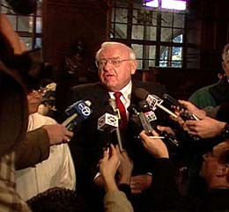
Deadline
Task:
- Discuss and debate answers to the questions below.
- Choose 6 of them to answer, individually. (Each is worth 5 marks)
- Choose the quotation on the accompanying page that best represents your view on capital punishment. Explain why. (5 marks)

I have always found that mercy bears richer fruits than strict justice.
ABRAHAM LINCOLN, speech, 1865
- Why do many perceive that the imposition of the death penalty is so unjust?
- What seems to be wrong in the American system? Can you find parallels in other countries? What about Canada?
- When Gov. Ryan created this commission, what might the feelings of the stakeholders have been? (Ex. police, prosecutors, defence attorneys, victims, convicted, general public)
- Which story was the most compelling to you (impacted you the most)? In what way and why?
- Why would the filmmakers have chosen to use so many stories of individuals?
- How did the conversations with those convicted of crimes (rightly and wrongfully) influence you? What similarities are there amongst them?
- Why is education seen as the key to this debate?
- How did the documentary change or reinforce your feelings about capital punishment?
- What is the significance of Governor Ryan’s commission? What long term impacts could it have?
- When the governor announced his decision, he reminded listeners that prosecutors have ‘awesome power’ because when someone is charged with a crime it reads, ‘United States v You’ or “Illinois v You’. What does he mean by this?
- How do you feel about Governor Ryan’s decision? Was he right to decide as he did? Explain your reasons.

