Exploring Religion

Focusing on the 3 religions that grew out of the Middle East

Common Beliefs

* *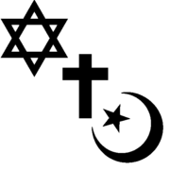Belief in the supernatural and in a spiritual world beyond our material world*
* *Belief in the existence of a soul*
* *A collection of sacred writing*
* *Organized institutions*
* *Shared practices and a strong sense of community*
* *Answers to important human questions*
* *A system of ethics to guide behaviour*
* *Significant founders or leaders who inspire*
* *A search for perfection or salvation*
* *A life of faith and worship*
* *A strong impact on the lives of the followers*

# Judaism

* The religion of the Jewish people
* Dates to more than 4000 years ago (2000BCE)
* Today there are 14 million Jews (Half in USA, quarter in Israel, quarter in Europe)
* Abraham is seen as the father of the faith; He fostered the belief in one God
* Jews believe that they are the chosen people because God made a special covenant (promise) with Abraham
* God promised Abraham that he and his wife Sarah would have a son and his descendants would be as many as there are stars in the sky
* 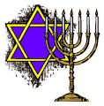The practice of circumcision dates from this time 🡪 it was performed as a sign that the boy is a descendant of Abraham
* In exchange for God’s promise of a “promised land” the Israelites must obey God
* The Exodus from Egypt took place around 1250 BCE
* Moses was given the Ten Commandments from God following the Exodus
* After 40 years, they reached Caanan, the fabled “Promised Land”
* A kingdom was established and Jerusalem was founded in 993 BCE
* King Solomon built a temple
* Over time the Israelites strayed from their beliefs and were reminded by various prophets of their need to be vigilant in the waiting for a Messiah
* In 587 BCE, Solomon’s temple was destroyed by the Babylonians and the Jews were exiled to Babylon
* Here, they worked hard to preserve their religious doctrines and practices
* They were strict about keeping the sabbath and eating the proper kosher food
* This made them appear unusual and odd to those who could not understand
* In 70 CE, the Romans destroyed a second temple that had been built in Jerusalem and outlawed Jewish education and finally drove the Jews out of Israel (the Diaspora)
* 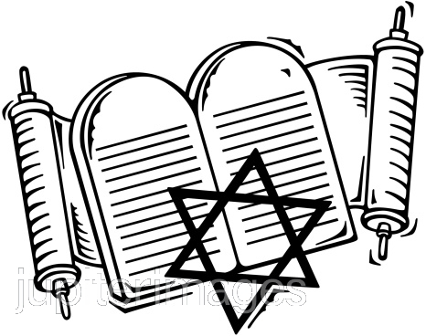These Jews fled to other Jewish communities around the Mediterranean, particularly in Spain, Portugal, and then into eastern and central Europe
* Further persecution followed throughout the Middle Ages, especially by Christian rulers
* Jews were accused of making money out of other people’s debt
* Christians were forbidden, by their religion, to lend money and charge interest but Jews were not
* Jews were barred from many professions so they naturally turned to banking and “money lending”
* Jews were eventually expelled from England, France, and even Spain
* Forced to live in separate and inferior ghettos

Christianity

* The religion of Christians
* They believe in the teachings of a man called Jesus, called Christ by his followers
* According to Christians, Jesus is the son of God
* He came to earth to save everyone from their sins (wrongdoings) by sharing in human suffering and sacrificing his life
* Began in what is now Israel and has spread around the world
* More than 1 billion followers
* The story of Jesus’ birth and childhood emphasize his humble heritage
* His baptism by his cousin, John was a sign of washing away sin and making a new start
* Jesus set out to help the weak and the poor, and spread a message of loving each other and serving each other: he seemed to perform miracles
* He forgave people who repented of their sins which many believed could only be done by God
* Repenting and being forgiven was the only way to bring God’s kingdom of peace and justice to earth
* He referred to God as “Father” and spoke with familiarity
* He taught that helping others was more important than Jewish law
* After 3 years of teaching, Jesus went to Jerusalem to celebrate the Jewish feast of Passover
* He knew that Jewish leaders were hostile towards him and they would see him killed
* The people welcomed him because they hoped he would overthrown the Romans and re-establish a Jewish kingdom
* They quickly turned against him when he didn’t do this
* Judas, one of his disciples, betrayed him and he was turned over to the religious leaders
* They demanded that the Roman governor, Pontius Pilate order his death
* He gave in and Jesus was crucified between two thieves
* 3 days after his death, his followers went to his tomb and he wasn’t there
* This was the resurrection which led to the ascension to heaven
* Christians believe that when they die, they will ascend to heaven to be with God and Jesus, in a state of bliss
* The New Covenant: although Jesus was without sin, he gave his life to pay for our sins and bring salvation to all
* Christians and Jews continued to be persecuted by the Romans
* Emperor Nero ordered the destruction of Jerusalem in 70 CE with the intent to get rid of all Jews and Christians
* In 313, Emperor Constantine converted to Christianity and made it an official religion and he founded Constantinople on the site of Byzantium
* In 325, he held a conference to create a statement of Christian belief 🡪 this was held in Nicaea and led to the creation of the Nicene Creed, and the doctrine of the Trinity
* In the 5th and 6th centuries the Roman Empire split in two
* Constantinople became the centre of the East
* Head of the church was called the Patriarch
* Rome became the centre of the West
* Head of the church was the Pope
* In 1054, there was a dispute between the two churches called “The Great Schism” and it led to two separate churches
* Roman Catholic and Eastern Orthodox sects still exist today

Islam

* Islam means obedience or peace by submitting to the will of Allah (God)
* The term Muslim means “obedient one”
* There are 1 billion Muslims in the world, primarily in the Middle East, North Africa and Asia
* This is the fastest growing religion
* Share some beliefs with Jews and Christians
* Most important moment was the revelation of God’s word to Muhammad in the 7th century
* Muhammad became the messenger of God or the Prophet
* He was born in Mecca and was raised by his uncle to be a trader and camel driver
* He was disturbed by the people’s desire to worship more than one God
* The people had lost the belief in Abraham’s God
* Around his 40th birthday, he was praying in a cave when the angel Gabriel spoke to him
* He continued to receive revelations all his life
* People in Mecca listened to his message but the authorities became suspicious
* In 622, he moved his followers to Medina
* This is the date that the Muslim calendar begins on
* Muslim beliefs
* Belief in Allah
* Belief in angels
* Belief in holy books
* Belief in the prophets of Judaism and Christianity (Adam, Abraham, Moses, David, and Jesus are all considered important prophets)
* Belief in the day of judgement and life after death
* Belief in predestination (God controls everything that happens)
* Islam has a code that involves many social responsibilities such as respect for parents, community, neighbours, and being honest, patient, and trustworthy
* It is forbidden to kill animals for sport
* The Five Pillars

1. The Shahadah🡪 the declaration of faith, repeated several times a day, “There is no God but Allah, and Muhammad is His messenger.”
2. Salah🡪 five daily prayers said at dawn, noon, mid-afternoon, sunset, after dark. They are said in a clean place. Muslims usually remover their shoes before praying to symbolize cleanliness.
3. Zakah🡪 obligation to give 2.5% of their savings every year to help the poor
4. Sawn🡪 fasting during the season of Ramadan. Eat and drink nothing during daylight hours. This reminds Muslims that they are equal with the poor and that they must not overindulge.
5. Hajj🡪 pilgrimage to the city of Mecca. All able bodied Muslims are expected to make this journey once in their life. Must make sure that the family is provided for before leaving on this journey.

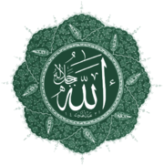

TABLE OF RELIGIONS

|  |  |  |  |
| --- | --- | --- | --- |
| Category | ***Judaism*** | ***Christianity*** | **Islam** |
| **Date of founding**  **Location** | 2000 BCE  (Abraham left the city of Ur in search of the Promised Land 🡪 Canaan) | 4 CE (birth of Jesus) in Jerusalem | 610 CE in Mecca, Saudi Arabia (also 622) |
| **Basic Beliefs** |  |  |  |
| **Sacred Texts** |  |  |  |
| **House of Worship** |  |  |  |
| **Special Diet Requirements** |  |  |  |
| **Symbols** |  |  |  |
| **Coming of Age Rituals** |  |  |  |
| **Role of the Prophets** |  |  |  |
| **Role of Abraham** |  |  |  |
| **Role of Jesus** |  |  |  |