The Gilgamesh Project
CHW 3MR
DUE: _____________________________
Epic tales can be tools for the historian to understand more about ancient societies, their beliefs, values, morals, and much more. ‘Gilgamesh’ and his adventures allow us just such a window into Babylonian culture. Read about the life of the real and fictitious Gilgamesh. Try to use that story as a basis for understanding what made the ancient Babylonians tick.
TASK:
Create an organizer (chart) to reflect the following headings. List as many words as possible for each heading and state the meaning of the word and, if possible, the historical or cultural significance to the time period.
The list of headings (or criteria) below is recommended for your chart. Some substitutions can be made by you, the researcher. You must have a minimum of 10 headings on your chart.

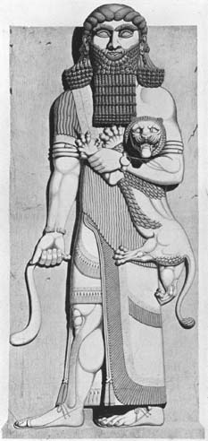
- places
- people
- gods/goddesses/deities/monsters
- occupations
- political system
- terminology (words from the time period)
- architecture
- weapons
- diet
- beliefs/ceremonies
- animals
- transportation
- technology
CHECKLIST:
- A minimum of 40 words overall (divided into at least 10 categories) are required for a level four in thinking
- Each of the 40 words used must have at least one point of evidence or explanation accompanying it for level four in knowledge
- Application of historical thinking concepts (HTCs) must be used well, in order to achieve a level four in application. These include: historical significance, cause and consequence, historical perspective, and continuity and change. The ethical dimension may also be used.
- The chart must be neat and complete with all headings used at least once for level four in application.
- Research must be complete with no errors in language, expectations of assignment, or spelling for a level four in communication. Clear point form can be used.
Marking Rubric

 | Level 4 | Level 3 | Level 2 | Level 1
Knowledge  (15 marks) | All 40 words have clear and elaborate explanations or evidence to support them | At least 35 words have clear explanations or evidence | At least 30 words have clear explanations or evidence although there are some parts unclear | At least 20 words have clear explanations or evidence although some parts are unclear
Thinking  (20 marks) | Words are appropriately placed in at least 10 categories. Choice of words shows thought and an understanding of life in Mesopotamia | Most words are appropriately placed in 10 categories.  Choice of words shows some thought and understanding of life in Mesopotamia | Fewer than 10 categories represented. Choice of words is limited.  Greater thought and understanding of Mesopotamia would improve this | Fewer than 10 categories represented.  Very little thought and understanding put into the word choice.
Application  (20 marks) | Work is well-organized and presented in a logical, thoughtful format  Concepts of historical thinking are applied with detail. | Work is relatively well-organized but a clearer presentation would have improved this.  Concepts of historical thinking are generally applied. | Organization is unclear and unattractive. More thought needed.  Concepts of historical thinking are minimal. | Not well thought out. Poorly planned.  Concepts are not discussed at all.
Communication  (15 marks) | Spelling and grammar are flawless.  Research is exemplary. Evidence of thorough research is clear. | Spelling and grammar are mostly flawless.  Research is complete and detailed. | A few minor spelling and grammar errors.  Research shows a lack of depth and detail. Not enough has been done. | More than 5 spelling and grammar errors. More care must be taken.  Research is not complete.

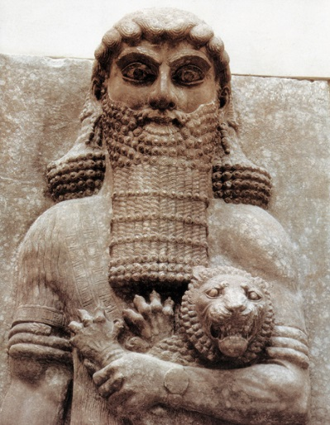
What you did well:

Areas for improvement:

