War: Greece vs. Persia

- The Persians first conquered the Greek city-states in Ionia
- In 500 BCE, the Ionians rebelled and were backed by Athens and Eretria, who provided both men and ships
- They destroyed the Persian city of Sardis but then the revolt collapsed when the Athenians and Eretrians withdrew their support

The Battle of Marathon
- These city-states were never forgiven by Persia
- In 490 BCE, King Darius led an invasion against Eretria and crushed it
- His army then landed at Marathon, just northeast of Athens
- Athenians and their allies marched an army of 10000 men but were significantly outnumbered by the Persian army.
- Athens won: used superior tactics and strong hoplite phalanx

The Second Invasion
- King Xerxes of Persia led another invasion into Greek territory
- To cross the Hellespont, Xerxes had his engineers construct a bridge made entirely of ships
- First confrontation took place in a narrow mountain pass called Thermopylae:
- At first, a small Greek army was able to hold off the Persians but a Greek traitor showed the Persians a secret route around the pass
- Realizing there was no way out, Leonidas (the Spartan commander) stayed on with his small force of 300 to fight and be slaughtered, allowing the Greeks to retreat to safety. It was one of the greatest and most famous gestures of self-sacrifice in ancient history.
- The Persians then marched on to an undefended Athens, they raided the city, looted and set fire to the Acropolis

Greek Warships
- Most powerful and famous warship Trireme
- Before a battle they stored the masts and sails, rowed into battle
- Crews of 200 men: naval officers, soldiers, archers & deckhands, but mostly oarsmen
- Trireme = Latin for “three oars” the oars were located at 3 different levels inside the hull

The Battle of Salamis (led by Themistocles, who had convinced Athens to build a navy)
- Persian ships were surprise attacked by the Greek army fleet
- Although the Greeks had fewer ships, theirs were more agile and destroyed the Persian ships that were blocked in
- The Persian invasion finally ends when the Spartan general Pausanias defeats the land army at Platea

War is Over: Persia Falls
- Most Greeks believe it was only a matter of time before the Persians struck again and they wanted to be ready
- Representatives from Athens and other city-states, meet and create the Delian League an alliance against any future aggression
- The Greeks and Persians continue to squabble until 449 BCE
- By this time, the Persian empire is weak and unstable
- By 330 BCE, the Persian empire is overrun by Alexander the Great
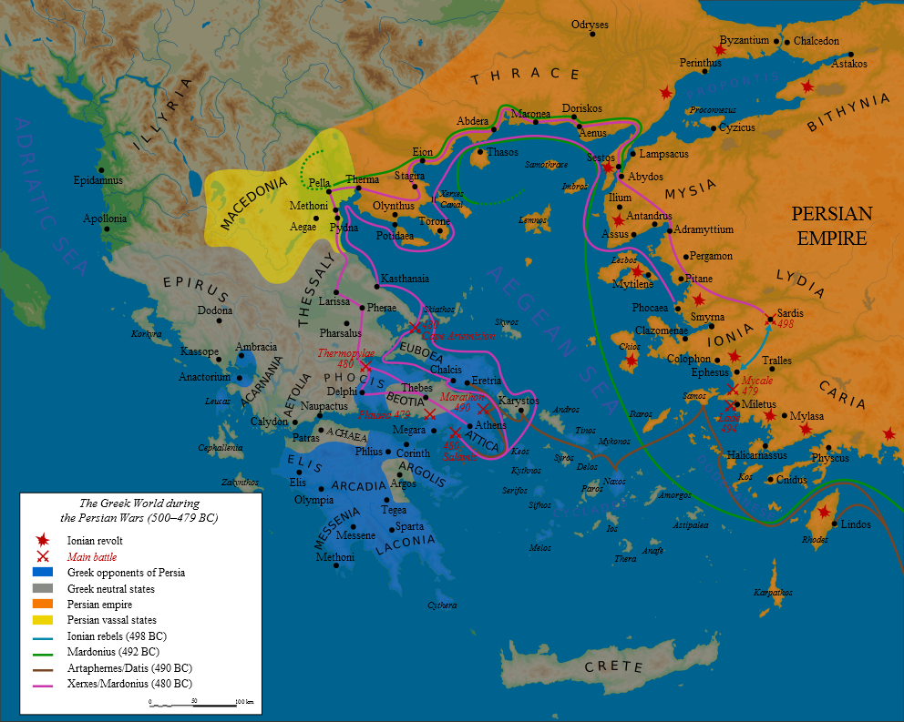
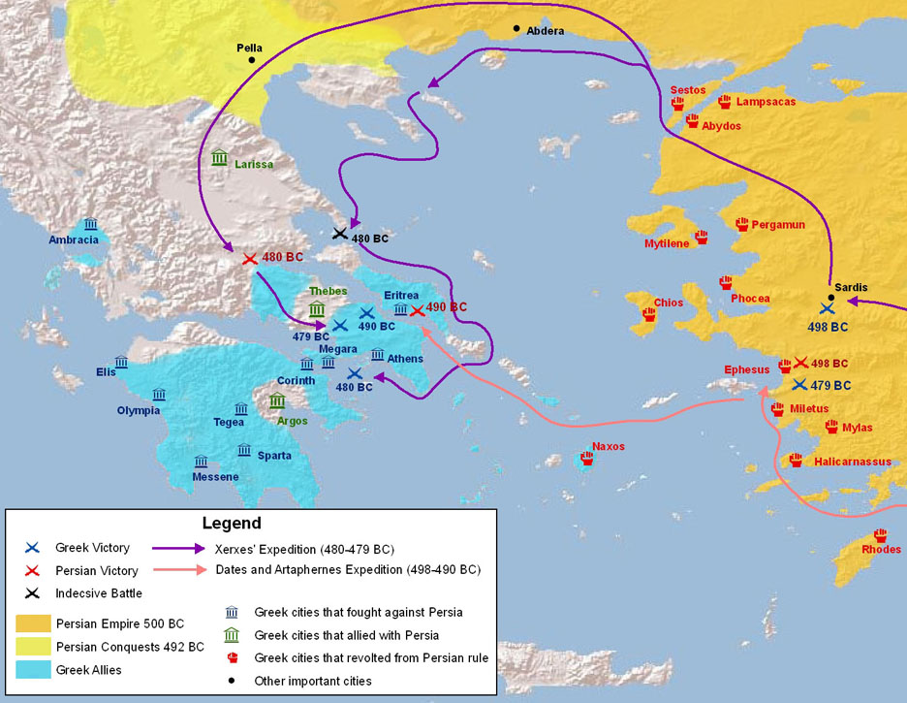
Persian War link

