Why Sir John A. Macdonald’s name should stay on our schools

John Geddes on the reason we remember Sir John A. and the importance of weighing historical figures based on more than their flaws
John Geddes
August 24, 2017
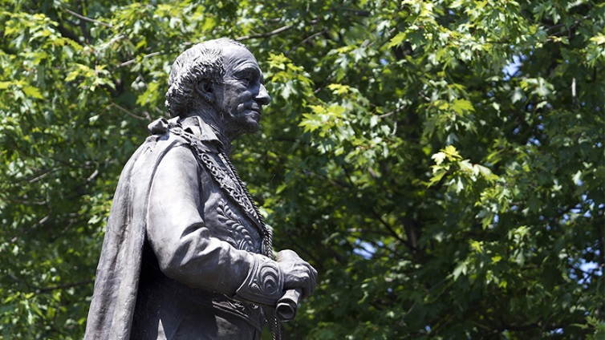
Sir John A. MacDonald’s statue in Kingston, Ont., on June 21, 2012. (Lars Hagberg/CP)

Hardly anyone minded when Prime Minister Justin Trudeau announced, back on June 21, National Aboriginal Day, that Ottawa’s imposing Langevin Block would be renamed, rather unimaginatively, the Office of the Prime Minister and Privy Council.
After all, Hector-Louis Langevin isn’t exactly a beloved household name. Who was this guy anyhow? The only Canadians likely to have any inkling are those who paid close attention to the Truth and Reconciliation Commission, which singled him out in its final report as a leading 19th-century architect of the federal government’s reviled residential schools policy, which blighted generations of First Nations people.
But history rarely allows for such tidy summings-up. Langevin was also a strong advocate for Quebec and a powerful figure in the governments of Sir John A. Macdonald. So if the plaque bearing Langevin’s name had to be unscrewed from the yellowish stone of a Second Empire style building across from Parliament, what about the many other buildings, old and new, that bear the name of the great prime minister who was his boss? There’s no denying that Macdonald was also a vocal advocate of assimilating First Nations, whose words on matters of race now make us cringe.
Still, the notion seems ridiculous. Who would seriously propose chiselling the name of Confederation’s most legendary figure off any façade? Well, the Elementary Teachers’ Federation of Ontario, that’s who. The union recently passed a resolution calling on Ontario boards of education to look at taking John A.’s name off the province’s schools. The teachers voted in the shadow of the bitter U.S. debate over taking down monuments to Confederate heroes from the Civil War, like the Robert E. Lee statue that was the flashpoint for the street violence in Charlottesville, Va.
Let’s stipulate the obvious: No thoughtful reader of history imagines that simply indicting figures of the past based on the standards of the present is a useful exercise. Few would survive such a culling. Consider arguably the two most revered political leaders of the past century, at least in the English-speaking world, Winston Churchill and Franklin Delano Roosevelt.
Commenting on the fate of Indigenous peoples of North America and Australia, Churchill once said, “I do not admit that a wrong has been done to these people by the fact that a stronger race, a higher-grade race, a more worldly wise race to put it that way, has come in and taken their place.” FDR’s wartime detention of Japanese Americans seems even worse since historians have turned up anti-Japanese views in his earlier writings, including a warning against “the mingling of Asiatic blood with European or American blood.”
There are countless examples like these covering all sorts of historical figures. Among the bronze statues on Parliament Hill, to bring this closer to home, stands a cheerful grouping representing the “Famous Five,” the leaders of the fight for political rights for women in the 1920s. Unfortunately, one of them, Emily Murphy, also infamously wrote racist screeds (in Maclean’s, it must be admitted) during the same era.
Murphy is not, however, memorialized on the Hill for her bigotry. She’s there because of her part in the fight to have women legally recognized as “persons.” And this suggests a way to bring some order to this argument. Among the key questions to ask, in considering which names and monuments should be preserved, is why a luminary was deemed worthy of being honoured, what aspect of their accomplishment earned that veneration, and how they are mainly remembered today.
So, in the case of those statues of Confederate generals, they were often erected in the South mainly to remind black citizens of a racist social order. Thus, the purpose of such monuments invalidates them, regardless of any complexity in what historians might tell us about Lee and the rest.
And then there is the quite different question, not of why a name was honoured in the first place, but what it has come to signify over time. Langevin’s legacy is now so narrowly associated with residential schools that his name conjures up little else for the few who know it. That alone is a strong argument for removing it from a major federal building.
By contrast, Macdonald’s towering reputation is about so much more that reducing his legacy to a racist taint—serious as it is—isn’t reasonable. His name still stands for a sweeping vision of Canada that he largely brought about, although his stature is seriously debated these days by historians. A similar case can be easily be made for Churchill and Roosevelt, and likely even Murphy. Their shortcomings are rightly probed by historians and taught in classrooms. But those dark failings can’t be allowed to eclipse all the rest.
There is no simple way to draft up an acceptable pantheon of historical heroes. Each biography calls up a unique response. We should start by relying on judicious historians to sift what a man or woman who lived long ago said and did, which is no easy undertaking. Then we should ask why they were deemed worthy of recognition, and whether that motivation still feels right to us. And if that’s the test, there will be no need to start dreaming up new names quite yet for schools named after Sir John A. Macdonald.

Maclean’s found at: http://www.macleans.ca/politics/ottawa/why-sir-john-a-macdonalds-name-should-stay-on-our-schools/

